LCR Reader Manual 2015
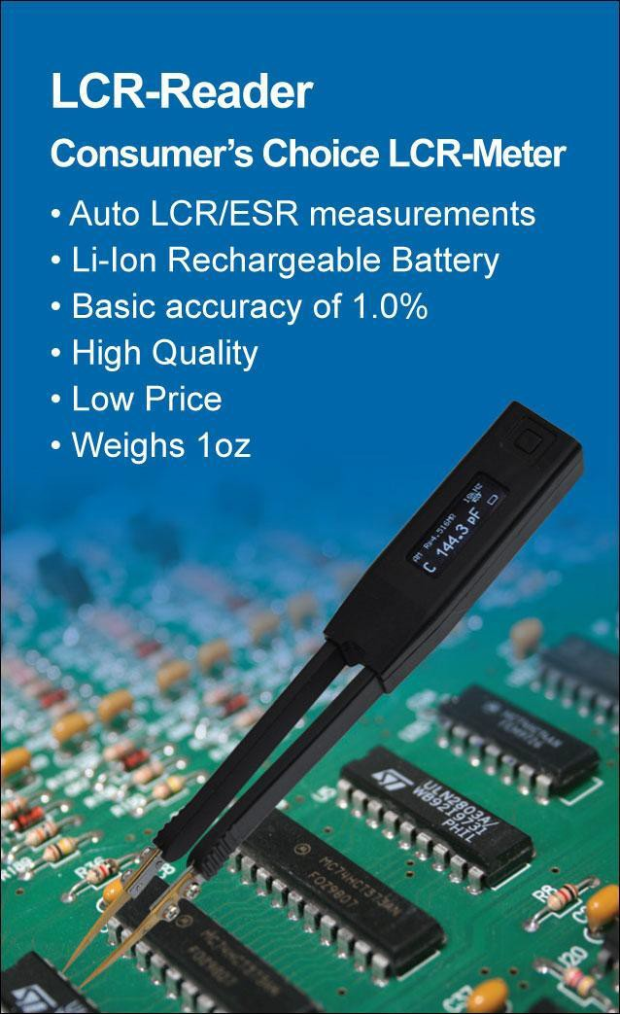

Getting Started

This section summarizes the basic operations of the LCR-Reader, including:
Overview: Overview of the LCR-Readers controls
Controls: Navigating the LCR-Reader
Display: Overview of the device's display functions and messages
Device Features: About the device's specifications

Overview

LCR-Reader is a Hand-held LCR-meter for Non-Professionals or hobbyists. It is the Smart Tweezers model for
a user looking for a device that provides an easy to use solution to testing and troubleshooting components that
Smart Tweezers offers but at a lower price.
The LCR-Reader is a small, powerful, high quality LCR-meter with the same accuracy as a bench top meters in a 1 oz. hand held unit. The device is a portable solution for testing and evaluating Surface Mount Devices (SMD), as well as testing and troubleshooting circuitry on printed circuit boards.

LCR-Reader feature a unique design that combines a set of tweezers as the probes to the small LCR- meter that offers high accuracy and a simple, easy-to-use design. With just one hand on the device, components can be evaluated by grasping the component between the tweezers' tips. When in contact, LCR-Reader automatically determines the type of component and measures for Inductance, Resistance, Capacitance respectively, while also measuring for secondary impedances. The sharp tips allow the device to measure all types of components to a 0201 size, including those already mounted on a PCB.

LCR-Reader requires no setting-up for measurements; automatic component identification determines the type of component, best test frequency for the type of component and measures accordingly for L, C or R. This information is then displayed on the OLED display, including the main impedance, component type and secondary parameters (such as the parasitic resistance for capacitors and inductance.) A 4-wire shielded connection to the tweezer probes ensures that there are low parasitic offsets.

The device provides an efficient option for professionals working with Surface Mount Technology. It's one handed design lets users focus solely on the component and task at hand, while leaving one hand free for holding other tools or taking notes.

Controls

The LCR-Reader features one-button navigation for a user-friendly experience. All mode selection and powering the device on is done with just one button.
Quick Controls
To wake the device up, press the button. The LCR-Reader's display will light up and show the main default screen.
To change between measurement modes (Auto, L, C, R, etc.), press the button; the device cycles through each mode.
To turn the device off, simply leave it alone; after 30 seconds of inactivity, it will turn off automatically.

Display

The LCR-Reader's OLED display is divided into 3 main sections.
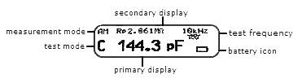
Primary Display: The Primary Display is located in the middle of the screen and uses the largest font. In the example, the main impedance value is 144.3 pF.

Secondary Display: The Secondary Display is located on the top of the screen. This is where the ESR values can be found and other minor impedance readings.

Measurement Mode: Shown in fig.1 as 'AM', this is the indication that the device will automatically determine the type of component being evaluated. The device will automatically select the measurement mode.

Test Mode: The LCR-Reader will display what test mode it is operating under. When measuring a Capacitance, the device will show C, R for Resistance, and L for Inductance.

Test Frequency: The device is evaluating components with the frequency shown.

Battery Icon: This shows the battery's remaining power.

Device Features

Technical Specifications

Test Frequency: 1 kHz, 10 kHz, 100Hz
Test Signal Level: 0.5 +/- 5% Vrms Sine wave Basic Accuracy: 1%

Measurement Ranges
Resistance R: 0.05 Ω to 9.9 MΩ
Capacitance C: 0.5 pF to 4999 µF
Inductance L: 0.5 uH to 999 mH

Physical Specifications

Size: 14.8 x 2.0 x 1.5 cm
(5.8 x 0.76 x 0.57 in)
Weight: 29 grams (1 oz.) Operating Temperature: 0ºC to 50ºC Battery Type: 3.7V LiPO
Rechargeable 220 mAh
Battery Life: 40 hours (2 hour charging cycle)

Warranty

Notice: To the best of our knowledge this document is believed to be accurate. The manufacturer reserves the right to change the information and does not assume any responsibility for omissions and/or errors found in this document.

Warranty: Manufacturer warrants his product to be free from defects in materials and workmanship for a period of one (1) year from the shipment date. Manufacturer warrants the following items for ninety (90) days from the date of shipment: rechargeable batteries, disks and documentation. During the warranty period, the manufacturer will, at its discretion, either repair or replace any product that proves to be defective. To exercises this warranty, write or call your local distributor. You will be given prompt assistance and return instructions. Please send the product with shipping prepaid to the indicated service facility. Repairs will be made and the product will be returned to you. Repaired or replaced products are warranted for the balance of the original warranty period, or ninety (90) days from the date of the repair.

This warranty does not cover the repair of any product whose serial number has been altered, defaced or removed. This warranty does not cover finishes (scratches on surface or screen), normal wear and tear, nor does it cover damage resulting from misuse, dirt, liquids, proximity or exposure of heat, accident, abuse, neglect, misapplication, operation outside of the environmental specifications, tampering, unreasonable use, service performed or attempted by an unauthorized service centers, failure to provide reasonable and necessary maintenance.

This warranty does not apply to defects resulting from product modification without manufacturer's express written consent, or misuse of any product or part. This warranty also does not apply to software, rechargeable batteries, damage from battery leakage, and improper polarity of the batteries or problems arising from normal wear or failure to follow instructions. This warranty does not cover OLED damage, physical damage to the tweezers handles; electrical damage of the product due to exposure to high voltage/charged capacitor or use of improper battery type.

The design and implementation of any circuit based on this product is the sole responsibility of the customer. Manufacturer does not warrant any damage that occurs as result of the user's circuit or any defects that result from user-supplied products. This warranty does not apply to repairs or replacements necessitated by any cause beyond the control of factory including, but not limited to, operation contrary to furnished instructions, shipping accidents, modification or repair by the user, neglect, accidents or others acts of God.

The foregoing is in lieu of all other expressed warranties and the manufacturer does not assume or authorize any party to assume for it any obligation or liability. The duration of any warranties that may be implied by law (including the warranties of merchantability and fitness) is limited to the term of this warranty. In no event shall the manufacturer be liable for special, incidental or consequential damages arising from ownership or use of this product, or for any delay in the performance of its obligations under this warranty due to causes beyond its control. This warranty is limited in duration to one (1) year from the date of the original purchase.

This warranty is in lieu of all other warranties, expressed or implied, including any implied warranty of merchantability or fitness for a particular use. The remedies provided herein are buyer's sole and exclusive remedies. Neither manufacturer, nor any of its employees, shall be liable for any direct, indirect, special, incidental or consequential damages arising out of the use of its devices and software even if manufacturer has been advised in advance of the possibility of such damages. Such excluded damages shall include, but are not limited to: costs of removal and installation, losses sustained as the result of injury to any person, or damage to property.

